*PROJECT 1:**Working with IAM Roles with S3 and bootstrapping with EC2*

**Task1: Creating a bootstrapped instance**

SS1: Edit user data

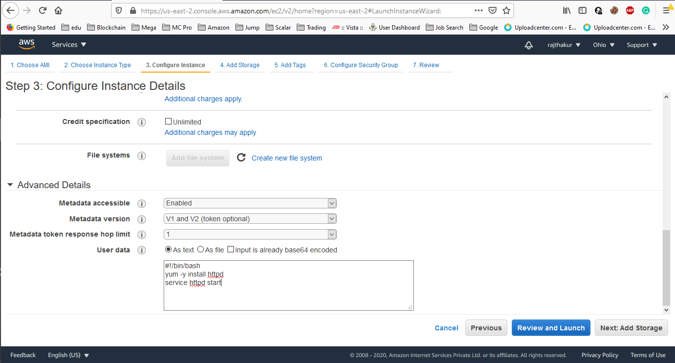

SS2: List of ec2 instances with description

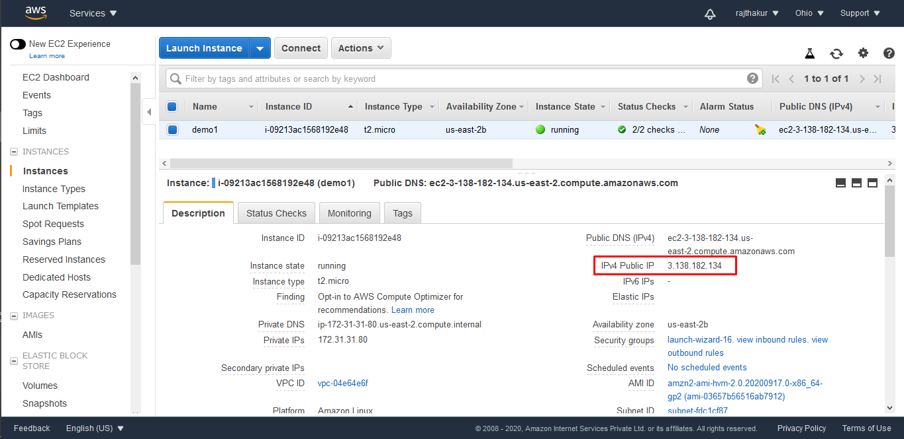

SS3: Test page

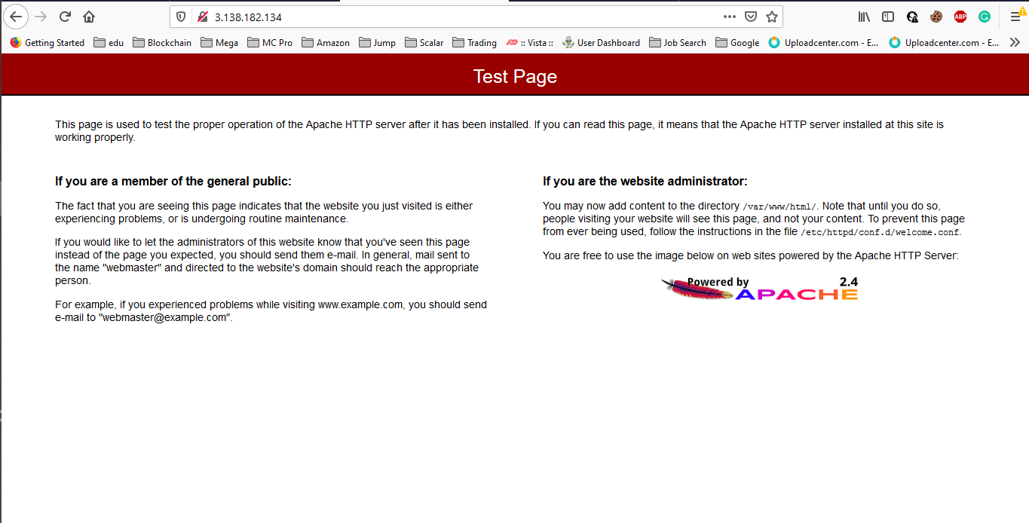

***Task 2: Checking bucket list and creating a new bucket from EC2 using IAM Roles***

SS1: Role Created

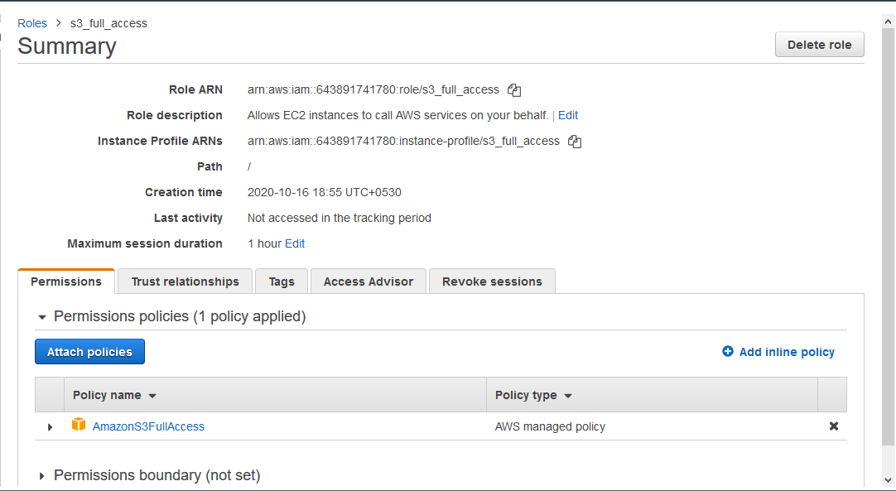

SS2: List of EC2 instances with security description that shows IAM Policies

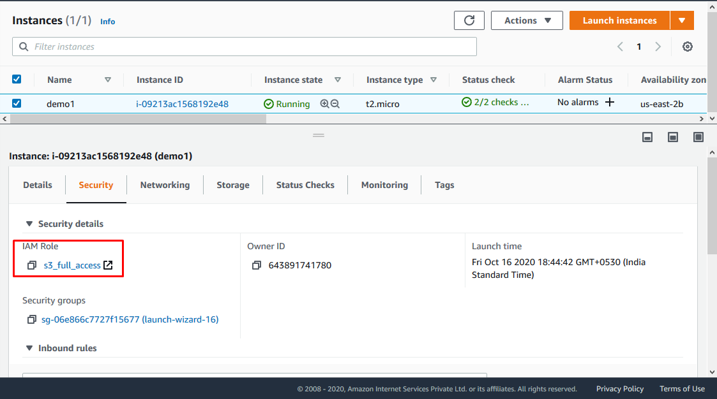

SS3: 3 commands to be executed **and outputs displayed**

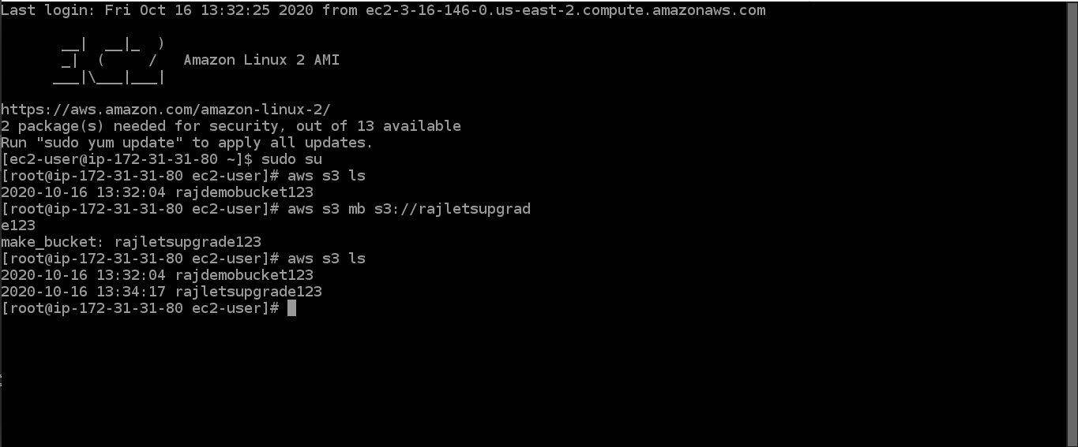

**Task 3: Hosting a webpage using the bootstrap script on ec2**

SS1: User data for installing apache and copying index.htm to its /var/www/html directory.

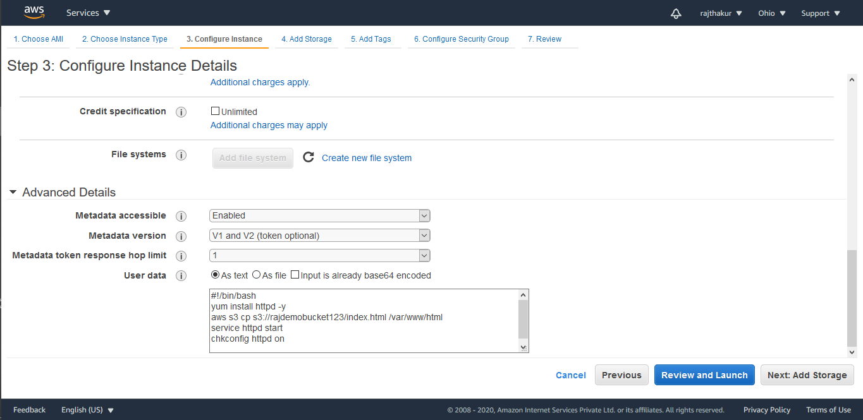

SS2: S3 bucket, index.html

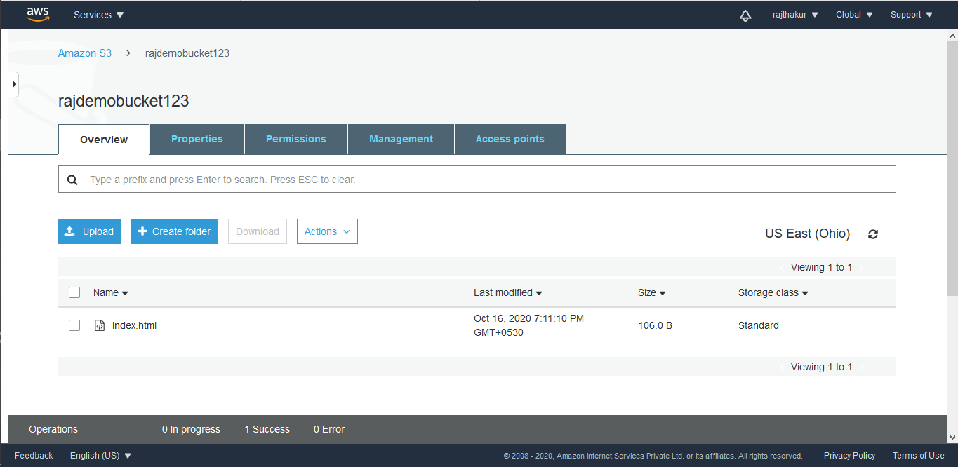

SS3: Testing using public IP

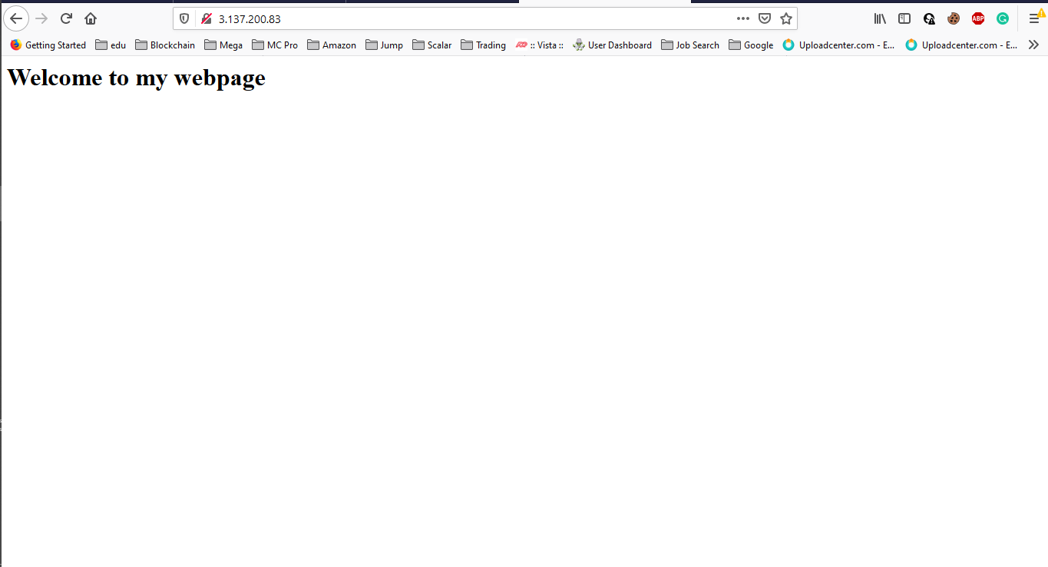

*PROJECT 2: Creating an EC2 instance in custom VPC*

**Task1: Create a VPC**

SS1: vpc created

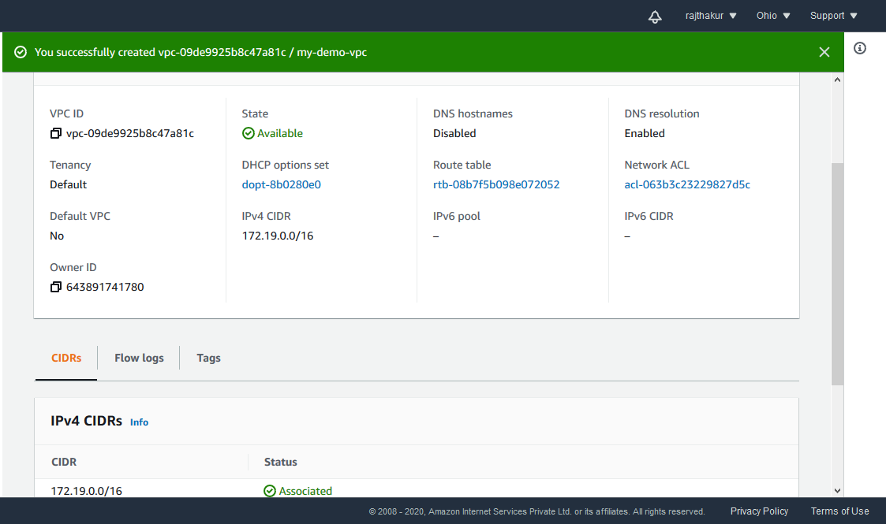

**Task 2: Create an Internet gateway**

SS2: Internet Gateway with vpc associated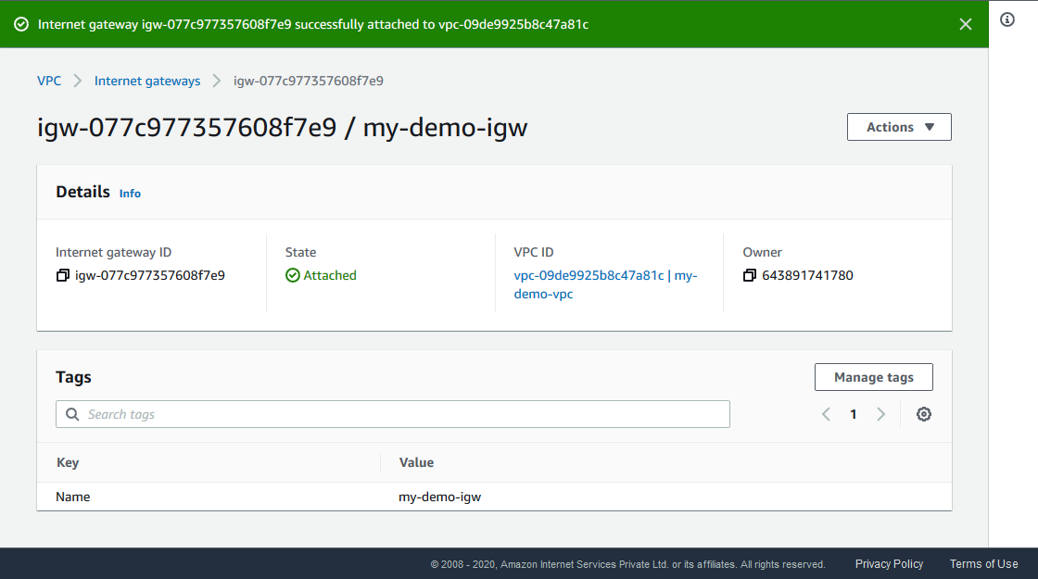

**Task3: Create a route table**

SS3: Route table with routes

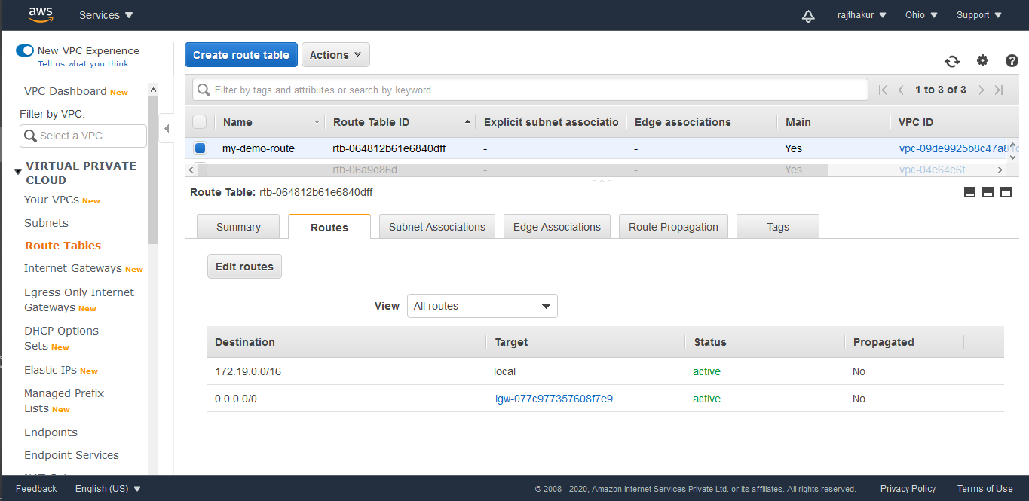

**Task4: Create a subnet**

SS4: subnet screen

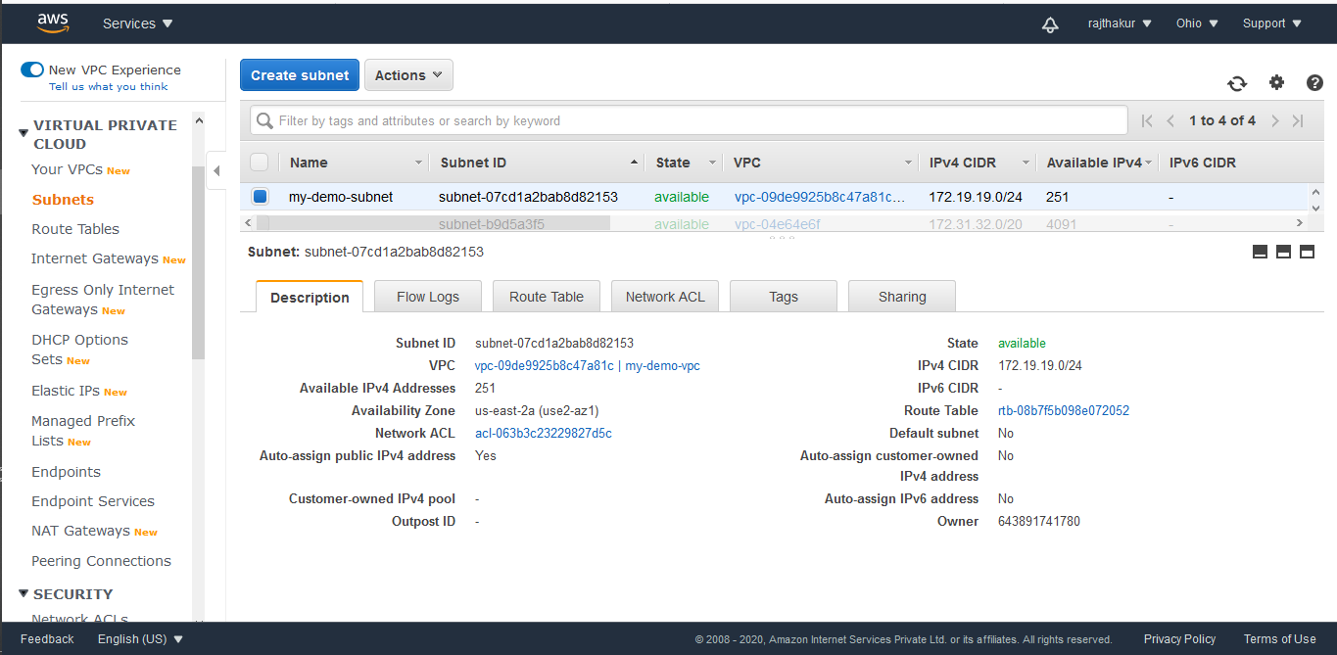

**Task5: Create an EC2 in custom vpc**

SS5: EC2 dashboard  
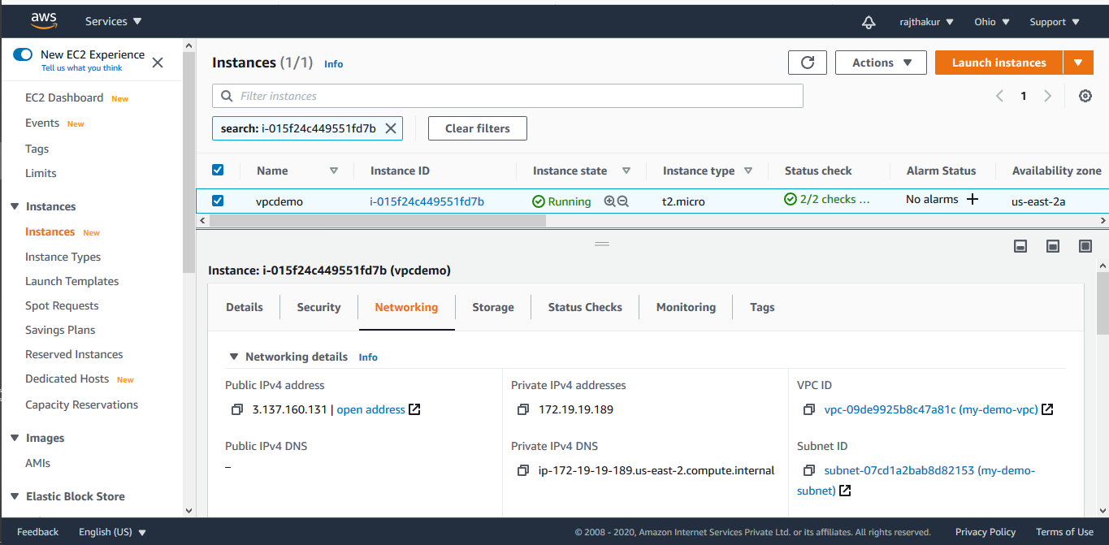

**Task 6:Check ipconfig in VM command prompt**

SS6: cmd prompt:ipconfig

